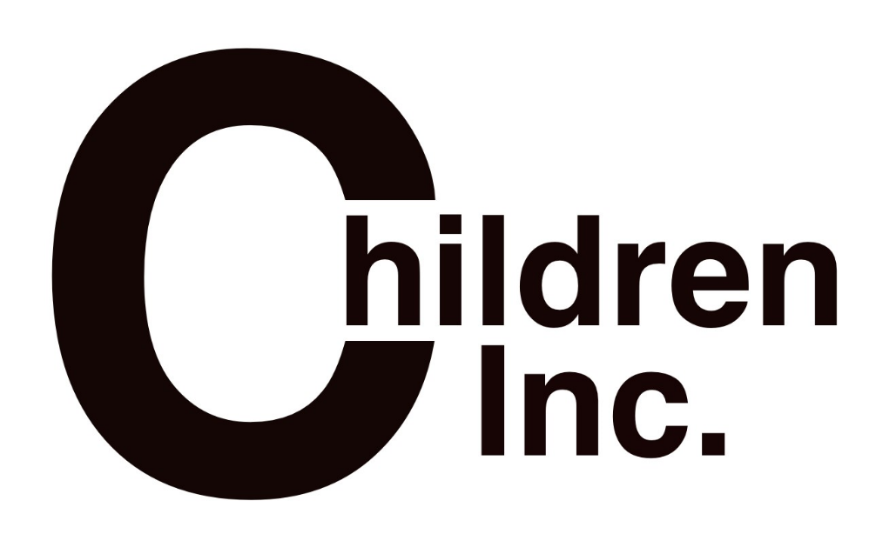
Sponsored By:

Children Inc Bristol

860 Clinton Ave

(Strong Smart Bold Community Center)

Bristol, VA 24201

(276) 696-9732

Enrollment Packet
(POLICIES AND PROCEDURES)

WE ARE A STATE LICENSED CHILD CARE CENTER WITH QUALIFIED PROGRAM INSTRUCTORS TO CARE FOR AND TEACH YOUR CHILDREN IN A PROGRAM BASED ATMOSPHERE. INSPIRING ALL CHILDREN TO BE STRONG, SMART, AND BOLD.

WELCOME TO CHILDREN INC. – A DIVISION OF GIRLS INCORPORATED OF BRISTOL

For more than 50 years, Girls Incorporated has provided vital educational programs to millions of American girls. Our innovative programs help girls confront subtle societal messages about their value and potential, and aim to prepare them to lead successful, independent, and complete lives.

The images of girls and women in society have expanded since Girls Incorporated of Bristol was founded. The organization has grown by providing affiliate services, research-based programs, training, communication, and advocacy. Now we ask you to imagine a Strong, Smart, and Bold new generation of girls, and all they will achieve.

Girls Inc. of Bristol started their first Outreach site in 1999 where they also serve boys. This has expanded to over 3 sites alone with programs within different schools and school systems. Through our Outreach, we are able to reach more children and adapt to the needs of each community by adjusting our programs to meet those needs.

As you enroll your child, we are entering a type of relationship with you for the development of your child during these critical formative years. Nothing can take the place of loving parents in the development of healthy well-adjusted children and we are here merely to assist you. To help we promise to provide as safe an environment that we possibly can for your child, and to assist in promoting the excitement of learning new and wonderful things.

The following handbook was designed to help communicate how we operate and what is expected in developing a healthy partnership. Please read the following to help in the understanding and the enjoying of this partnership.

It would take several lengthy books to explain every detail about our operation and philosophy of childcare. If we have failed in the “Handbook” to answer any questions, or if you would like it discussed on a more personal basis, call or come by and we will be glad to talk to you. If there is any way we can be of service to you or your families please feel free to contact the agency and we will address the need as best we can.

Operating Hours:
SCHOOL YEAR
(August-May)
2:00 P.M. – 6:00 P.M. MONDAY THRU FRIDAY (These hours are subject to change based on needs)

SUMMER PROGRAM
(June –July)
7:00 A.M. – 5:30 P.M. MONDAY THRU FRIDAY

School Year (Aug-May):
Girls Inc. office hours will be 10:00 AM TO 6:00 PM Monday thru Friday at our main campus. Children are to arrive no earlier than 2:00 during the school year. If a child did not attend school, they will not be allowed to come to Children Inc. Children must be picked up by 6:00 PM. IN AN EMERGENCY PLEASE CALL AS SOON AS POSSIBLE.

Fee Schedule for Children Inc.
$10.00 Registration Fee (One-Time)
$35.00/Week Spring Semester (January – May)
$60.00/Week Summer Session (June – July)
$25.00 Summer Activity Fee
$35.00/Week Fall Semester (August – December)

Payment is expected if your child attends or does not attend, this holds their spot so that they will still have childcare.

Winter Storm Closing
In case of inclement weather, we will close with the Bristol Virginia School System. If the weather turns bad after the children arrive, we will close at the President/CEO’s discretion. If you have questions on our schedule changes, please try the following.

Call our center (276) 669-8686
Watch WYCB channel 5 for Bristol VA School Closings
Check WCYB website WWW.WCYB.COM
Girls Incorporated of Bristol – Facebook Page

Holidays
New Year’s Eve & Day Thanksgiving Eve, Day, & Friday
Good Friday Memorial Day
July 4th Labor Day
Christmas Eve and Day

Drop-off and Pick up
The parent or adult responsible for dropping the child off is expected to bring their children into Children Inc. and make sure a staff has been aware of the presence of the child before you leave.

Please pick up your child on time. In cases of emergency please call. If we have not heard from anyone and none of the contacts can be reached, according to our license we are required to call the Department of Social Services and/or the Police after you are fifteen minutes late. There is a charge of $1.00 per minute for late pick-up.

Only those on the emergency card will be allowed to pick up your child. Your additional children cannot be left unsupervised anywhere in the building, automobile, and playground. Please collect all schoolwork and memos from your child’s cubby each day before you sign them out. If your child is outside when you arrive to pick them up, leave them until you have picked up their things and signed them out.

Playground Safety
One staff is in charge of the play areas to ensure that debris and garbage are clear. Staff will also be placed in strategic positions to supervise the entire play area. One staff is to circulate among children while playing. All resilient surfacing will be checked to make sure that it covers all fall zones. An adequate number of staff will be in sight and sound supervision at all times.

Injury Prevention / Emergency Preparedness
We will monitor all children at all times. The children are to be with staff at all times. During business hours, one adult shall be in charge of the administration of the center. Accidental injury forms are logged and evaluated. When there is a significant amount of injuries in a particular place there will be an evaluation on that area to see what can be done to ensure that the problem is eliminated. We have an Emergency preparedness plan on file, should you like to review it. In the Emergency Plan, our safe place is the Bristol Regional Medical Center. In the event of an evacuation, we will place a note on the main door and call all parents of the location change.

Medication
If a child must be given medication while signed in at Children Inc., the medication administrator must be informed, and the proper paperwork filled out. Only the medication administrator will be allowed to administer medication. The medication MUST be in the original bottle and the bottle must be clearly labeled with the child’s name, directions, and dosage. Any non-prescription medication will be given only if there is a medication letter filled out in our office. That note is good for 10 days and should be updated as needed. Please pick up medication at the end of the needed time. If medication is not picked up within 48 hours, it will be properly disposed of. Please inform the staff if the medication needs to be refrigerated.

Health Concerns
Each child must have received all immunizations by the time of enrollment and must be current according to age level as prescribed by the Virginia Department of Health child health standards. Please make us aware of any chronic physical problems and allergies your child may have.

Sick children cannot be cared for at Children Inc. A child may not remain at the center if they are thought to be ill or contagious. If a child becomes ill during the day, their parent or guardian will be contacted to immediately pick them up. The following is a partial list that outlines when a child will not be allowed to stay and must be picked up immediately.

Fever: A child who has a fever of 99.9 or higher, must be picked up
Vomiting/Diarrhea Must be picked up.
Pink Eye/ Conjunctivitis: Must be picked up; and be on medication 24 hours before they can return.
Streptococcus: Must be picked up; and be on medication 24 hours before they can return.

When children at the center have been exposed to a communicable disease listed in the Department of Health’s current chart (ex. COVID-19, Influenza, etc.), the parents shall be notified within 24 hours of the next business day. In the event of a life-threatening disease, this will be reported immediately. Also, if the child has been exposed outside of Girls Inc., the staff should be informed immediately.

By signing this enrollment packet, you agree to not hold Girls Inc. of Bristol/Children Inc responsible for any illness or communicable disease that your child comes into contact with while at our facility.

Confidentiality
All information obtained for the purpose of enrolling your child is confidential. The information will not be released to anyone.

To protect our members, we monitor all internet activity. E-mails, instant messaging, and chat conservations are not permitted in our computer lab or our electronic devices. If your child is found to be participating in these activities her computer time will be revoked. We record and monitor all computer activity and it is the property of Girls Incorporated of Bristol, meaning any of its affiliates and representatives. The activity we monitor whether deemed confidential, trivial, directly, or indirectly associated with Girls Inc., will be used as we see fit.

Girls Incorporated does not discriminate based on age, race, religion, disability, origin, sex, or gender identity.

Girls Incorporated is a licensed day care facility; we are mandated reporters and are required to report any suspected child abuse or neglect. A custodial parent or guardian shall be admitted to Girls Incorporated as required by the code of Virginia.

Food
During summer program Children Inc. will provide breakfast, lunch and a snack. During the school year Children Inc. will provide snack. If the children are out of school during the school year for a scheduled school closed day and come to Children Inc. for a full day, they will need to bring a packed lunch.

Chain of Command
If you have a concern and wish to discuss it with us please see the Site Director. If they have not resolved the issue to your satisfaction, then see the Director of Operations or Director of Programs followed by the President/CEO.

Dress Code
Please dress your child so they are able to manage their clothes themselves. Dress them in comfortable clothes and shoes suitable to play outside or at the gym. In summer we request each child have a pair of tennis shoes either worn every day or an old pair left here; we are frequently on the playground or on field trips which require foot protection. Clothing that is disruptive, inappropriate, or represents a bad attitude will not be tolerated. (Examples: alcoholic beverages, foul language, unacceptable logos or pictures) Please try not to dress your girl in coats, jackets, and sweaters with tie strings around the neck.

Personal Belongings
We are not responsible for items brought into Children Inc; your child is responsible for their personal belongings. Cell phones are allowed and children can bring them as long as the Director of Programs deems their behavior appropriate. Phones will not be allowed during program/homework time and can only be out during free time. If the rules are not followed, the phones will be taken and returned when the girl leaves.

Cell Phone/Social Media Policy
Children Inc. members are NOT allowed to have their cell phones during program and homework time. If a staff sees that a child has their cell phone, then the child will be asked to put it up. If the phone remains out the staff will place it in a safe space until the child is picked up. Children can have cell phones in their backpacks turned off. If a parent/child needs to contact one another in an emergency, then the Girls Inc. phone will always be made available. No videoing or taking photos (by the child) is allowed while a child is signed in at Children Inc. Posting to social media while signed in at Children Inc. is also not allowed (by the child).

Parking Area
We apologize for the limited parking at Children Inc. But we ask that you watch for children and parents walking to and from cars. While walking in, assume that drivers cannot see you and hold your child’s hand at all times.

Licensing Information
As a licensed day care center with the state of Virginia, we maintain a positive, safe environment for our girls. Our staff to children ratio must be 1 to 18 with all staff trained in CPR and First Aid, along with specific training within their program area. We are an agency of the United Way of Bristol. We have found that there are many young girls who can benefit from our programs and grow to be Strong, Smart, and Bold.

Girls Incorporated Of Bristol Programs
Girls Incorporated of Bristol has been providing services for the young girls in our community since 1950. Our programs offer creative, structured environments that empower girls to become all they can throughout their lives. With a long successful history, we offer programs that cover many different areas of importance for young girls. Our programs cover three different core essential service areas, within each content area, there are between 50 and 250 different “sub lessons” covered throughout each program.

Healthy Living
Children will participate in program activities and experiences that provide them with the knowledge, skills and encouragement to develop and sustain a healthy lifestyle leading to:
- an increased knowledge of the dangers of unhealthy choices
- increased level of physical activity
- an improved body image
- improved nutritional habits and consumption of healthy foods
- decreased or delayed substance use and risky sexual activity

Academic Enrichment and Support
Children will participate in program activities and experiences that expand on and support their school-based learning and engagement leading to:
- an improved outlook and performance in school
- having set personal, educational, and career goals
- improved academic/school performance
- having educational aspirations beyond high school

Life Skills Instruction
Children will participate in program activities and experiences that build the learning, skills, and behaviors that enable them to function independently and live a productive and fulfilling life leading to:
- increased persistence and resilience
- ability to delay gratification
- improved self and emotional control

Authorization of Participation & Transport
I understand that the Children Inc program operates in a group format and that my child is responsible for their belongings. I authorize and give my permission for my child to participate in all program activities and program evaluations, unless notified in writing. This includes water activities and Girls Inc. transportation, staffed by the Girls Inc. staff or other related personnel. I may be asked to contribute items for special activities.

Authorization for First-aid/ Emergency Medical Care
I grant my permission to Girls Inc. staff and or medical personnel to give my child first aid including preventative measures such as sunscreen. In the event of an emergency, I give my permission to medical staff selected by Girls Inc. of Bristol to secure and administer treatment (including hospitalization) and provide necessary transportation for my child. I understand that Children Inc. will notify me as soon as possible in the event of illness, injury or emergency. If requested or required, I agree to pick my child up. In the event that my child or any member of the immediate household develops any reportable communicable disease, as defined by the State Board of Health, I will report it to Girls Incorporated of Bristol.

In the event of an accident, the program instructor will fill out accident forms to document the event and to better inform you of the details surrounding the occurrence. If injuries are incurred First-Aid will be administered and emergency medical care contacted if needed. The parent (s) or authorized person will be contacted by the phone numbers listed on the card. For the welfare of your child, please keep the phone numbers listed on the card updated. Both your current work numbers and the emergency phone numbers must be current in case we need to contact you in the event of injury or illness.

Agreement of Fees, Attendance and Suspension Information
Fees are made payable to Girls Inc. of Bristol and paid at the front desk or mailed to: 885 Clinton Avenue, Bristol, VA 24201. I agree to accept full responsibility for my child’s fees. Spring and Fall sessions will be $35 a week and Summer session will be $60 a week with a $25 activity fee. Any fees not paid in advance or by the 1st of each month are subject to a late fee charge of $10.00 on the 10th of each month. I understand that since payment is due in advance, unless previous arrangements have been made, when payment or arrangements have not been made by the 15th of each month then it will result in automatic suspension from the program. If I default on fees I understand that I will be responsible for the costs of collection. There are no refunds or credits for absence, sickness, or mishaps. I understand that there is a late fee of 1.00 for every minute per child for any pick-up after closing hours. I will be notified if the inclusion of my child is not in the best interest of the program or the child (endangerment, discipline, and disrespect). If the situation can not be resolved, Girls Inc. of Bristol reserves the right to suspend or remove any child from the program at any cost.

Photo Release
My child may be photographed and or videoed. Girls Inc./Children Inc. reserves the right to use this photo and or video for Girls Inc. and United Way promotions.

Insurance
The parent and or guardian are responsible for all medical coverage in the event of an accident/ emergency.

Early Dismissal, School Out Days and Food
I understand that on early dismissal days that my child will need a nutritious lunch and drink sent with her if the school isn’t providing it. Also, when Bristol Virginia Schools are out for snow or dismisses early Children Inc. will be closed. If the weather turns bad after school you will be asked to pick your child up early. On any day the schools are out and your child comes to Children Inc., you will need to pack a lunch.

Parental Agreement
All of the above is correct and I will update all information as needed. I have received and read the Parent Handbook and Enrollment Policies. I agree to abide all the policies/procedures and to communicate effectively with staff members.

Behavior Expectations and Discipline Policy
Girls Inc. and Children Inc. are dedicated to ensuring a safe and nurturing environment and we want all children to enjoy and benefit from the fun and healthy activities we offer. This responsibility rests not only on the Girls/Children Inc. staff, but also with parents/guardians and children. We focus on positive reinforcement and do not condone negative behaviors, belittling a child, talking rudely to a child or screaming/yelling at children.
This site uses the “Buck System” as their behavior modification system. It is designed to reward the children as well as hold them accountable for inappropriate behavior. During the school year they are able to “spend” their bucks in our “store”. During the summer, if they have 5 or more bucks they get to attend the buck trip at the end of the summer.

A buck will be taken from the child if one of the following behaviors happens:

- Leaving the room without asking
- Being disrespectful to staff/ or other children
- Not listening to staff
- Using inappropriate language / or using words to hurt someone (bullying)
- Using cell phone/electronic during undesignated time
- Causing harm to someone or their belongings
- Playing in the bathroom
- Acting inappropriately during program or while on a field trip
* In the event of physical altercation with another person, this will automatically result in a suspension*
*Other behaviors not listed could result in the loss of a buck or a suspension if it is deemed a violation of the rules by the Site Director, or Director of Operations/Director of Programs*

Buck Information
1st - 9th Buck = Warning/Parent conversation/Loss of free day or field trip
10th Buck = Suspension warning
11th Buck = One day suspension
12th Buck = Two-day suspension
13th Buck = Three-day suspension
14th Buck = Possible expulsion from program

Parent Conferences
We encourage all parental involvement – so if you have any concerns, please talk to your Site Director or another staff member about having a parent conference. All conferences will be conducted with the Site Director and the Director of Operations or Director of Programs present.
Program Instructors are not allowed to meet individually with parents, but you are always welcome to express any general concern with ANY staff at ANY time.
If there is a serious violation of the rules or a child demonstrates consistent inappropriate behavior, the Site Director, Director of Operations or Direct of Programs may reach out to a parent/guardian and request a conference to discuss solutions.
As always, if you have any questions or concerns regarding our expectations in our enrollment agreement or in our behavior agreement – please reach out to the Site Director or the Director of Operations/Director of Programs.
Please refer to the Enrollment Agreement that is signed upon initial enrollment to see all expectations and rules for Girls Inc and Children Inc.
--------------------------------------------------------------------------------------------------------------------------------------------------
Parent/Child Behavior Agreement / Enrollment Agreement
Please sign below that you and your child understand and are in compliance with the information that has been given to you in the Girls Inc/Children Inc Behavioral Agreement and Enrollment Agreement above:

________________________________________ ____________________________________
Parent Signature Date

________________________________________ ____________________________________
Child Signature / Name Date

Please list any previous childcare: ____________________________________________

Enrollment Date: __________________________________

Termination Date: _______________________________________

